**GOOGLE MAPS API ON ANGULAR 5 PROJECT**

**REF:**

<https://angular-maps.com/>

<https://medium.com/@pablo_ezequiel/google-maps-and-angular2-aad18640b5ef>

<https://angular-maps.com/api-docs/>

<https://stackblitz.com/edit/angular-google-maps-demo?file=app%2Fapp.component.ts>

IN ORDER TO ACHIEVE THIS, WE HAVE TO INSTALL ***@agm/core*** USING NPM ON ANGULAR 5 APP:

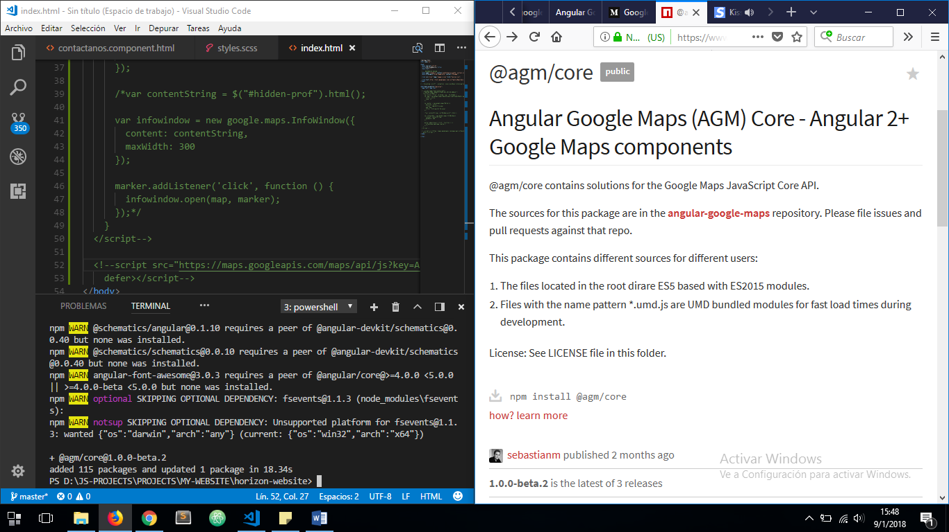

***app.module.ts***

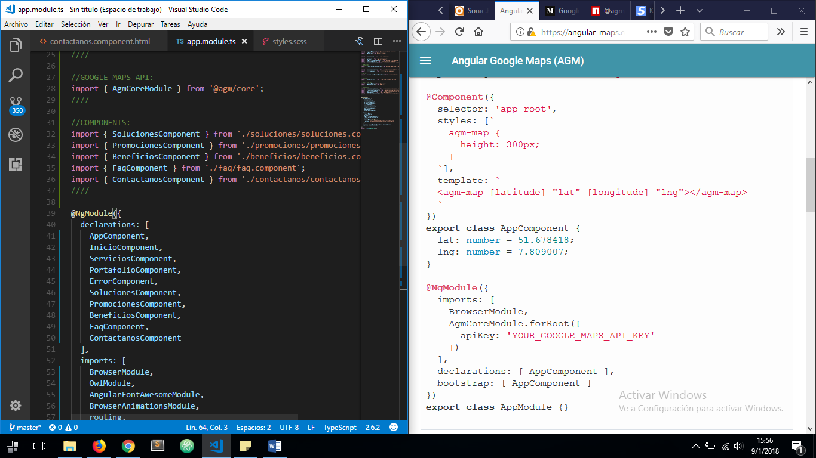

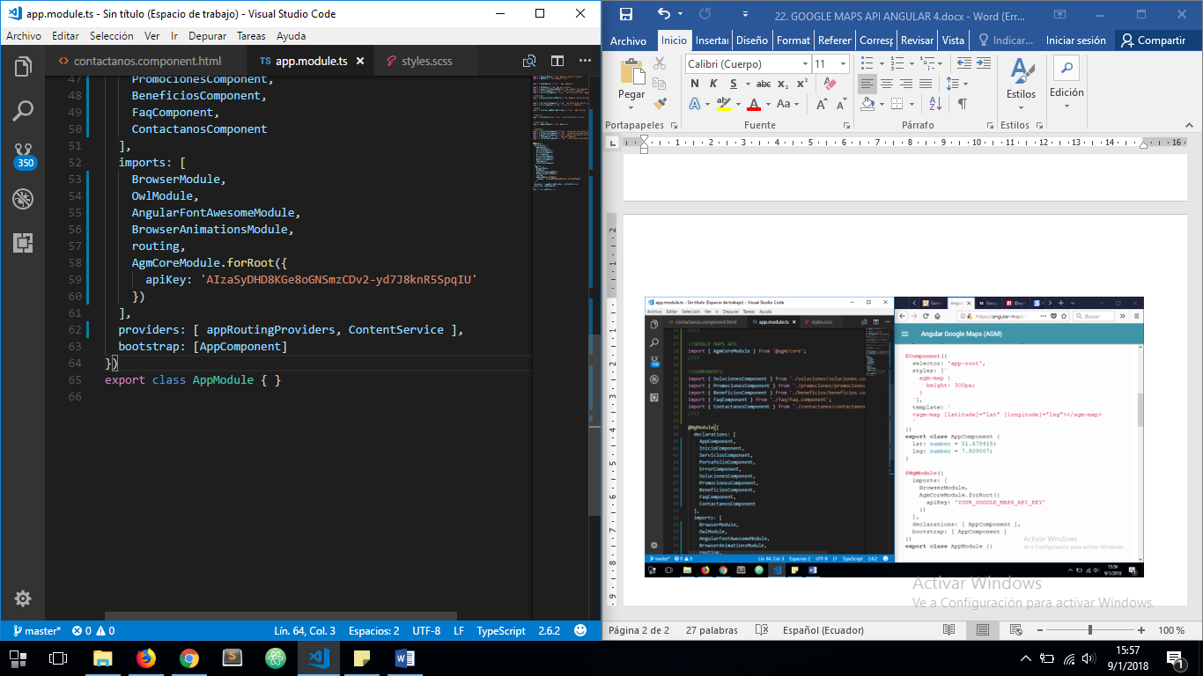

ON THE COMPONENT YOU WANT TO ADD THE MAP:

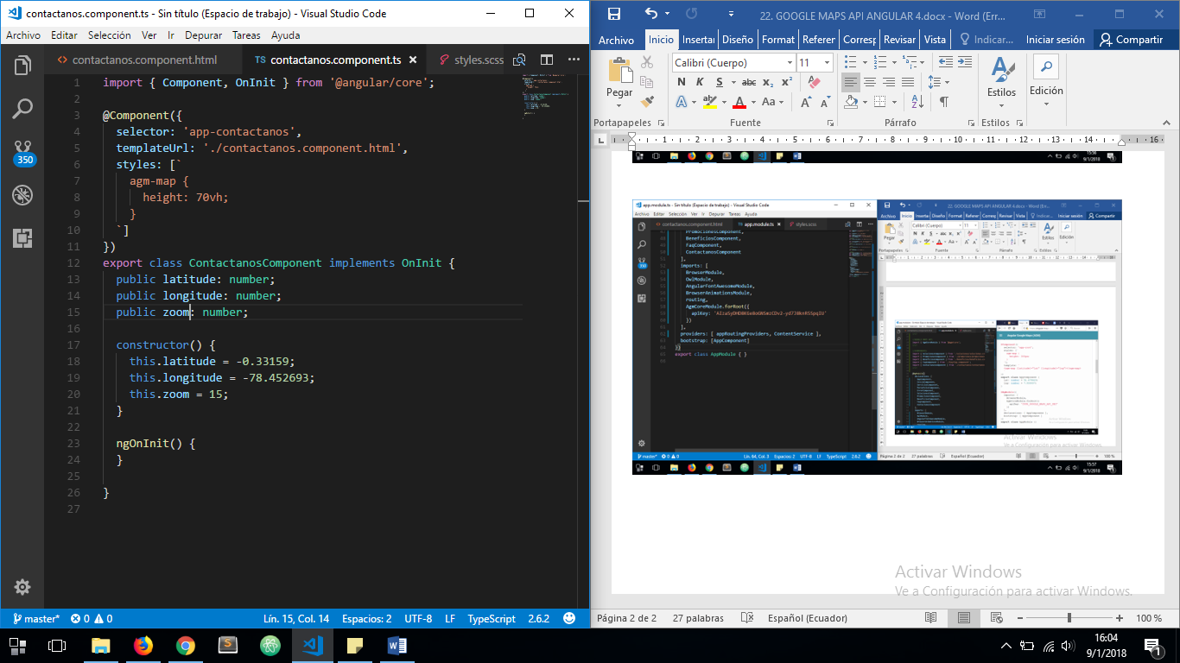

ON THE TEMPLATE:

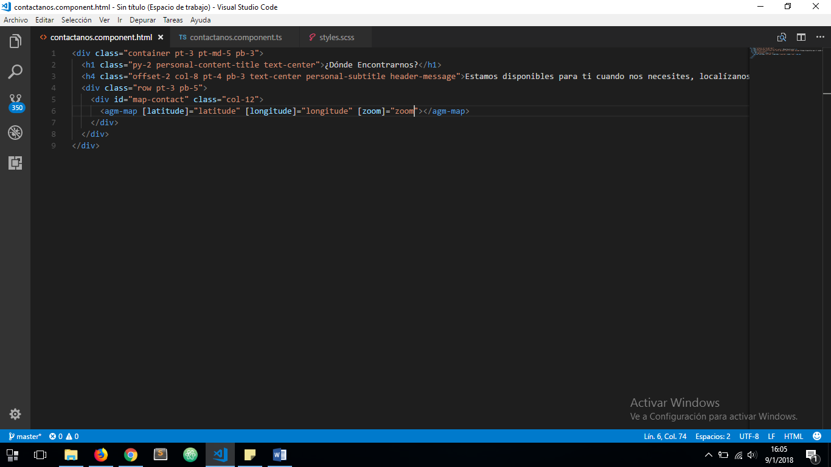

AND THE RESULT IS:

